Correlation Analysis of Clinical, Demographic, and Familial Risk Characteristics Associated with Diabetes Status

A Final Project Report
By
UWAIFO OBED
Dataset: Pima Indians Diabetes Database
Source: UCI Machine Learning Repository
Software: R
June 2026

Research Question
How are selected clinical, demographic, and familial risk characteristics related to diabetes status and to one another among women in the Pima Indians Diabetes Dataset?

- Introduction
Type 2 diabetes mellitus is one of the most prevalent chronic diseases in the world. It affects hundreds of millions of people, and the numbers keep rising. The condition involves impaired glucose regulation and insulin resistance, and it can cause serious downstream problems — cardiovascular disease, kidney failure, neuropathy, vision loss. None of that is trivial.
What makes diabetes particularly well-suited to correlation analysis is that its risk profile involves multiple interacting factors: how much glucose is circulating in the blood, how much body fat a person carries, how old they are, what their family history looks like. These variables don't operate in isolation. Understanding how they relate to each other, and to diabetes status, is genuinely useful — not just for prediction, but for identifying which measurements carry the most diagnostic signal.
The Pima Indian population in Arizona has been studied for decades precisely because of its unusually high diabetes prevalence. Knowler et al. (1978) documented a rate roughly nineteen times higher than comparable populations in Rochester, Minnesota. That disparity made this population a natural focus for diabetes epidemiology, and it's why the Pima Indians Diabetes Dataset has become one of the most widely used benchmarks in diabetes research. The dataset captures clinical measurements, demographic characteristics, and a familial risk score from adult women of Pima Indian heritage.
This report uses that dataset to investigate two related questions. First, which variables are most strongly associated with diabetes status? Second, how do these variables relate to one another? Correlation analysis — using point-biserial, Pearson, and Spearman methods selected by the characteristics of each variable pair — provides a structured way to answer both without making causal claims the data cannot support.
- Methods
  - Dataset Description
This study used the Pima Indians Diabetes Dataset, obtained from the UCI Machine Learning Repository. The data contains medical and demographic information from adult women of Pima Indian heritage — a population with a historically documented high prevalence of Type 2 diabetes. The original dataset had 768 observations across 9 variables.
Table 1 shows the full variable list with types and descriptions. For the purposes of this analysis, variables were grouped into three categories: clinical measurements (Glucose, BloodPressure, BMI), demographic characteristics (Age, Pregnancies), and a familial risk indicator (Diabetes Pedigree Function). Outcome was the binary response variable.

Variable | Type | Category | Description
Pregnancies | Integer | Demographic | Number of pregnancies
Glucose | Integer | Clinical | Plasma glucose concentration (mg/dL)
BloodPressure | Integer | Clinical | Diastolic blood pressure (mmHg)
SkinThickness | Integer | Excluded | Triceps skin fold thickness (mm)
Insulin | Integer | Excluded | 2-hour serum insulin (mu U/ml)
BMI | Numeric | Clinical | Body mass index (kg/m²)
DiabetesPedigree  Function | Numeric | Familial Risk | Genetic diabetes risk score
Age | Integer | Demographic | Age in years
Outcome | Binary | Response | Diabetes status (0 = No, 1 = Yes)
Table 1 – Variable descriptions, types, and categories in the original dataset.
  - Data Cleaning
Data cleaning addressed two problems: biologically impossible values encoded as zeros, and variables with excessive missingness.
Several variables contained zero values that have no physiological meaning. A living person cannot have a blood pressure of zero, a BMI of zero, or a plasma glucose of zero. These zeros were not true measurements — they represented missing data entered as a placeholder. BloodPressure had 35 such values (4.6%), BMI had 11 (1.4%), and Glucose had 5 (0.6%). All were recoded as NA before any analysis.
Two variables were excluded entirely. Insulin had 374 zero values — 48.7% of all observations. SkinThickness had 227 (29.6%). Including variables with that level of missingness would produce correlation estimates driven more by imputed or removed data than by actual measurements. There was also reason to believe the missingness was not random: patients with more severe metabolic dysfunction may have had more measurements taken, or vice versa. Given that uncertainty, exclusion was the more defensible choice.
After recoding impossible values and dropping Insulin and SkinThickness, listwise deletion was applied. Any row with a remaining NA was removed. This reduced the sample from 768 to 724 observations — a loss of 44 rows (5.7%). The final dataset contained seven variables: Pregnancies, Glucose, BloodPressure, BMI, DiabetesPedigreeFunction, Age, and Outcome.

Stage | Observations | Change
Original dataset | 768 | —
After excluding Insulin & SkinThickness | 768 | Variables removed
After listwise deletion | 724 | −44 rows (5.7%)
Table 2 – Sample size at each stage of data cleaning.
  - Exploratory Data Analysis
Exploratory analysis focused on understanding the distributions of all variables before selecting correlation methods. Descriptive statistics (minimum, maximum, mean, median, quartiles) were calculated for the cleaned dataset. Histograms were generated for all six continuous variables to assess distributional shape — particularly skewness, which directly determines whether Pearson or Spearman correlation is more appropriate.
Normality was also evaluated using the Shapiro-Wilk test. One limitation of this test is sensitivity: at n = 724, it will flag even minor departures from normality as statistically significant. The test results were therefore read alongside the histograms rather than treated as definitive.
Scatterplots with fitted regression lines were produced for the two variable pairs selected for Pearson correlation — Glucose vs BMI and Age vs BloodPressure — to confirm approximately linear relationships before proceeding.
  - Correlation Analysis
Correlation analyses covered 11 variable pairs, grouped by method. The method for each pair was chosen based on variable types and distributional characteristics.

Point-Biserial Correlation
Point-biserial correlation was used when one variable was the binary Outcome variable (0 = no diabetes, 1 = diabetes) and the other was continuous. Point-biserial correlation is mathematically equivalent to Pearson correlation when one variable is dichotomous coded as 0 and 1, so R's cor.test() function with method = "pearson" was used directly. Four pairs were analysed: Outcome vs Glucose, Outcome vs BMI, Outcome vs Age, and Outcome vs BloodPressure.

Pearson Correlation
Pearson correlation was used for two pairs involving continuous variables with approximately linear relationships and no severe distributional violations: Glucose vs BMI and Age vs BloodPressure. Scatterplots were inspected before finalising this choice. For Age vs BloodPressure, mild heteroscedasticity was observed — blood pressure variance appeared greater at younger ages than older ages. Pearson was retained given the large sample size and the absence of a more serious violation, but this is acknowledged as a limitation.

Spearman Rank Correlation
Spearman rank correlation was used for five pairs where the distributional characteristics of at least one variable made Pearson inappropriate: Age vs Pregnancies, Pregnancies vs BMI, Pregnancies vs Glucose, DiabetesPedigreeFunction vs Glucose, and DiabetesPedigreeFunction vs BMI. Pregnancies is count data with strong right skew. DiabetesPedigreeFunction is heavily right-skewed with a long tail. Both violate the distributional assumptions Pearson works best under.
In all Spearman analyses, tied ranks were present — particularly in Pregnancies, where many women share the same count values. R cannot compute exact p-values with ties, so asymptotic p-values were used. At n = 724 this is appropriate.
All tests used a significance threshold of α = 0.05.
  - Supplementary Group Comparison
BloodPressure produced the weakest point-biserial correlation with diabetes status. Correlation coefficients measure linear association across all individuals, but they don't directly show whether the two groups differ in average values. To check this, mean and standard deviation of BloodPressure were calculated separately for diabetic and non-diabetic participants, and a Welch two-sample t-test was run to compare group means. The Welch test does not assume equal variances between groups, which is appropriate for observational data.
- Results
  - Descriptive Statistics
The cleaned dataset contained 724 observations across seven variables. Table 3 shows descriptive statistics for all variables. The average participant was 33 years old with a mean BMI of 32.47 kg/m² — well into the obese range by standard classification. Diabetes prevalence in the dataset was 34.4%, meaning roughly one in three participants had diabetes.
Variable | Min | Q1 | Median | Mean | Q3 | Max
Pregnancies | 0 | 1 | 3 | 3.87 | 6 | 17
Glucose (mg/dL) | 44 | 99.75 | 117 | 121.88 | 142 | 199
BloodPressure (mmHg) | 24 | 64 | 72 | 72.40 | 80 | 122
BMI (kg/m²) | 18.20 | 27.50 | 32.40 | 32.47 | 36.60 | 67.10
DiabetesPedigreeFunction | 0.078 | 0.245 | 0.379 | 0.475 | 0.628 | 2.420
Age (years) | 21 | 24 | 29 | 33.35 | 41 | 81
Outcome (0/1) | 0 | 0 | 0 | 0.344 | 1 | 1
Table 3 – Descriptive statistics for the cleaned dataset (n = 724).
  - Distribution Assessment
Figures 1 through 6 show histograms for all six continuous variables. The Shapiro-Wilk test returned statistically significant results for all variables, but given the large sample size, visual inspection was the primary basis for method selection.
BloodPressure had the most symmetric distribution — roughly bell-shaped, centred around 70 mmHg. Glucose was broadly symmetric with a slight right tail. BMI showed moderate positive skew, with the bulk of values between 20 and 40 kg/m² and a tail extending to 67. Age, Pregnancies, and DiabetesPedigreeFunction all showed substantial right skew. Age was heavily concentrated at younger values (the median was 29, mean 33) with a tail stretching to 81. Pregnancies had a spike at low values typical of count data. DiabetesPedigreeFunction had the most pronounced skew, with a long right tail extending past 2.0.
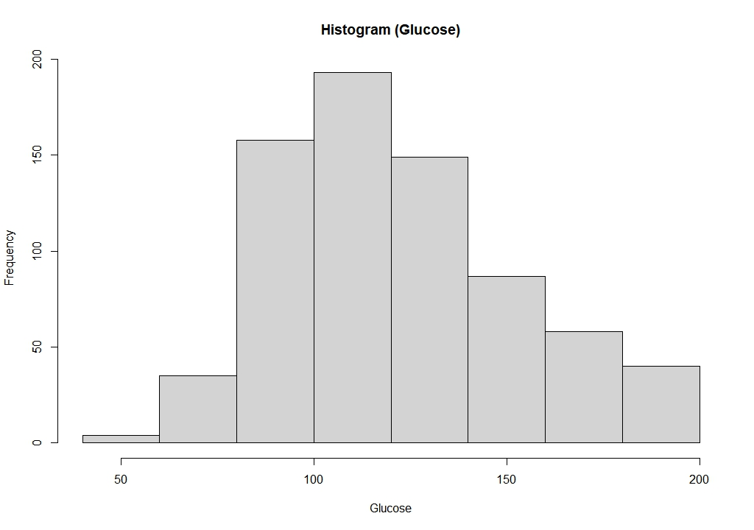
Figure 1 – Histogram of Glucose (Broadly symmetric distribution)
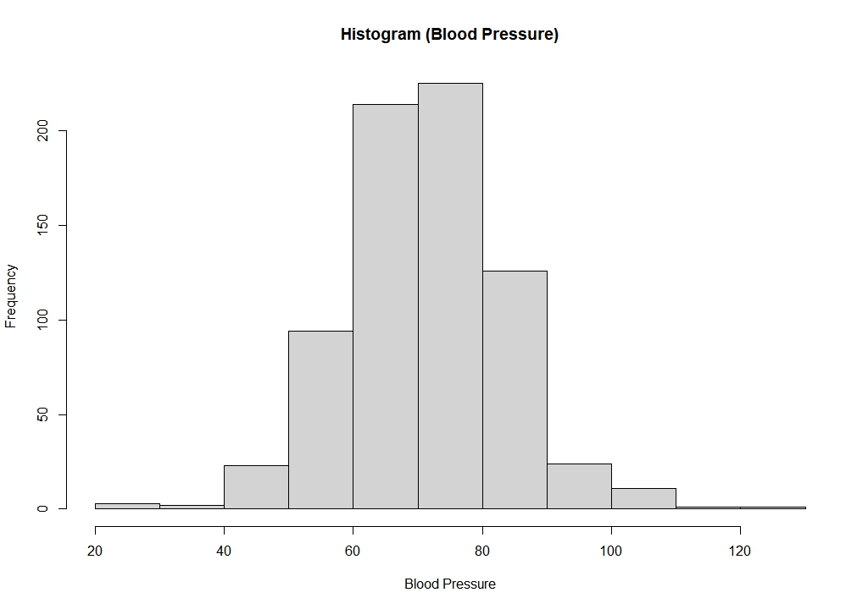
Figure 2 – Histogram of BloodPressure (approximately normal, closest to symmetric)
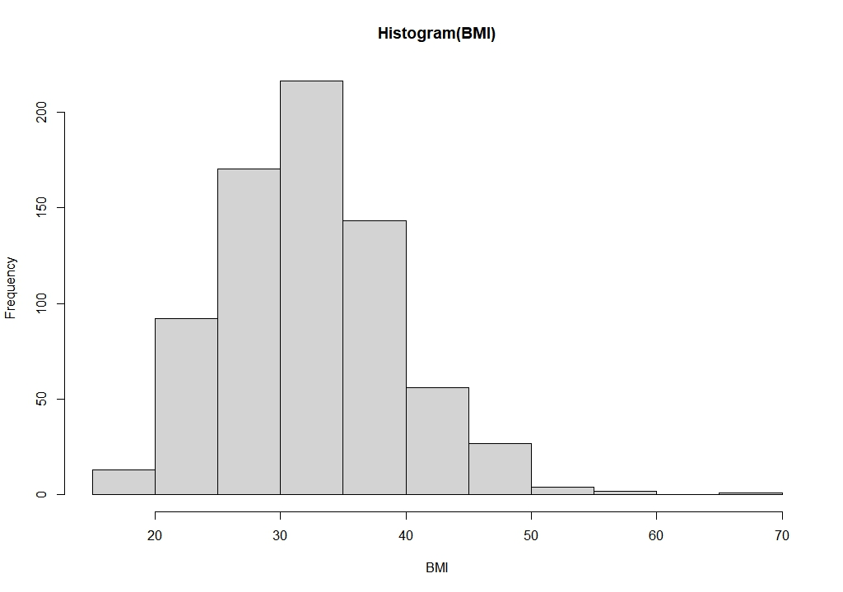
Figure 3 – Histogram of BMI (moderate right skew with tail extending toward 67 kg/m²)
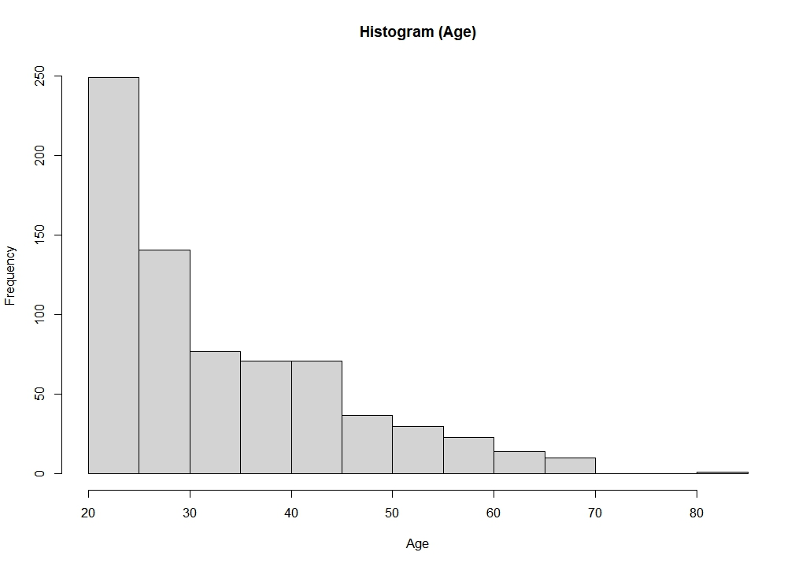
Figure 4 – Histogram of Age (strong right skew, concentrated at younger ages)
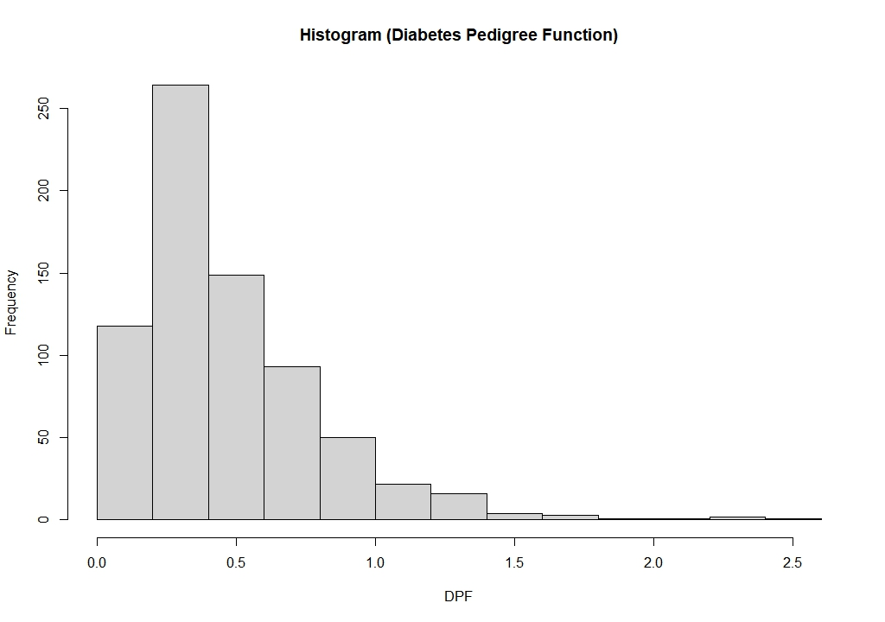
Figure 5 – Histogram of Diabetes Pedigree Function (heavy right skew with long tail)
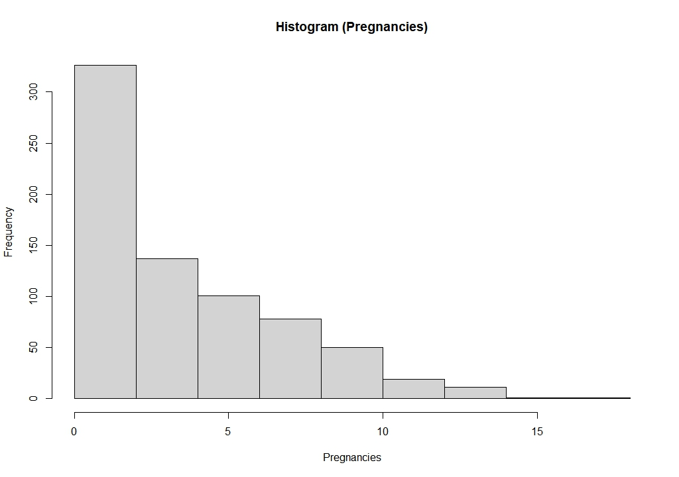
Figure 5 – Histogram of Pregnancies (count data, strongly right-skewed)
Variable | W Statistic | p-value
BloodPressure | 0.990 | < 0.001
Glucose | 0.969 | < 0.001
BMI | 0.979 | < 0.001
Age | 0.878 | < 0.001
Pregnancies | 0.905 | < 0.001
DiabetesPedigreeFunction | 0.837 | < 0.001
Table 4 – Shapiro-Wilk normality test results for all continuous variables (n = 724).
All variables returned significant results, though at this sample size even minor deviations from normality produce significant p-values.
  - Scatterplots (Pearson Assumption Checks)
Figures 7 and 8 show scatterplots for the two variable pairs selected for Pearson correlation. Both show positive linear trends. Glucose vs BMI has considerable scatter around the regression line, consistent with the weak positive correlation eventually found (r = 0.223). Age vs BloodPressure shows a clearer upward trend but with greater variability at younger ages — the mild heteroscedasticity mentioned in the methods. Neither plot showed extreme outliers dominating the fitted line.
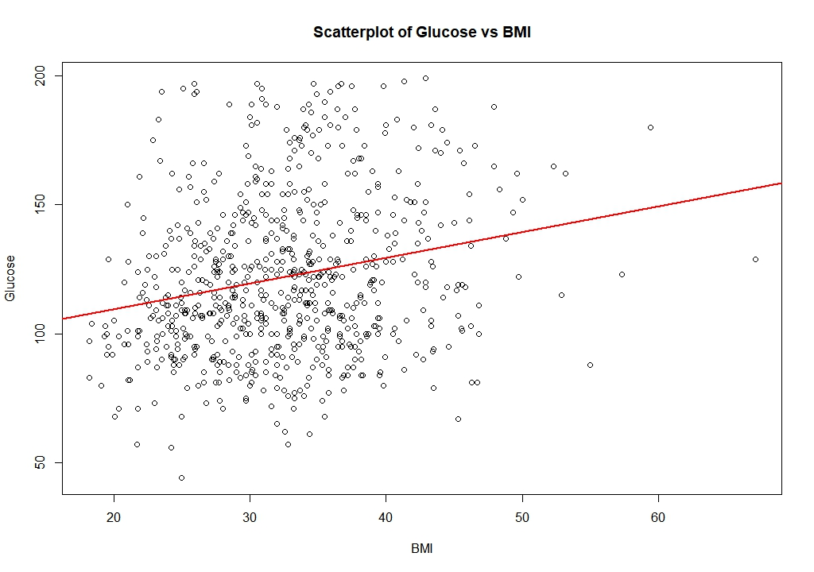
Figure 7 – Scatterplot of Glucose vs BMI with fitted regression line (red). Approximately linear positive trend with substantial scatter.

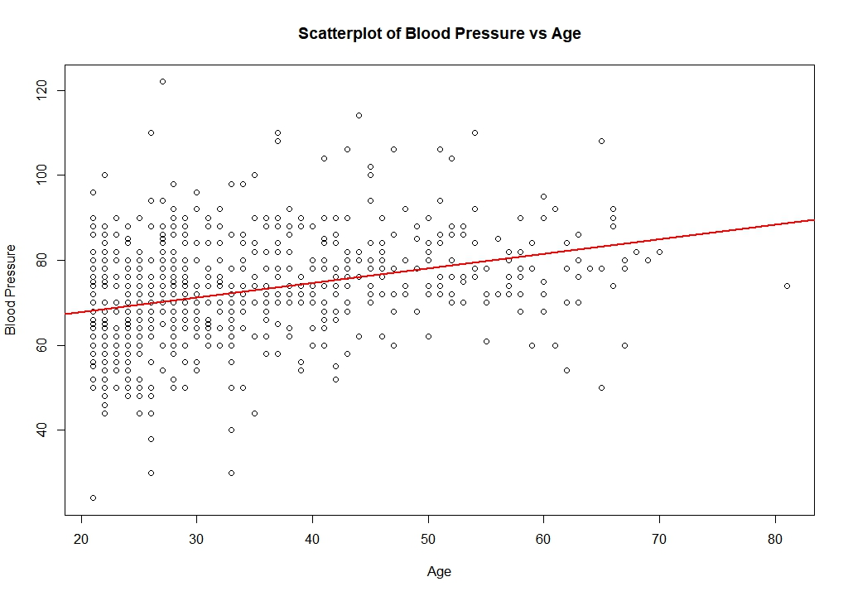
Figure 8 – Scatterplot of BloodPressure vs Age with fitted regression line (red).
Positive trend with mild heteroscedasticity — greater variance at younger ages.
  - Correlation Results
Table 5 presents all 11 correlation coefficients with their corresponding p-values and methods. Figures 9 through 11 show the correlation matrix heatmap.
Variable Pair | Method | r / ρ | p-value
Outcome vs Glucose | Point-Biserial | 0.488 | < 0.001
Outcome vs BMI | Point-Biserial | 0.299 | < 0.001
Outcome vs Age | Point-Biserial | 0.246 | < 0.001
Outcome vs BloodPressure | Point-Biserial | 0.167 | < 0.001
Glucose vs BMI | Pearson | 0.223 | < 0.001
Age vs BloodPressure | Pearson | 0.325 | < 0.001
Age vs Pregnancies | Spearman | 0.617 | < 0.001
Pregnancies vs BMI | Spearman | −0.002 | 0.967
Pregnancies vs Glucose | Spearman | 0.138 | < 0.001
DPF vs Glucose | Spearman | 0.086 | 0.021 ⚠
DPF vs BMI | Spearman | 0.129 | < 0.001
Table 5 – Correlation results for all 11 variable pairs. ⚠ indicates the weakest significant finding — interpret cautiously given no multiple-comparison correction was applied.
Among the point-biserial correlations, Glucose showed the strongest association with diabetes status (r = 0.488), followed by BMI (r = 0.299), Age (r = 0.246), and BloodPressure (r = 0.167). All four were statistically significant (p < 0.001).
Among the Pearson correlations, Age vs BloodPressure produced a moderate positive coefficient (r = 0.325) and Glucose vs BMI a weaker one (r = 0.223). Both were significant.
The strongest Spearman result was Age vs Pregnancies (ρ = 0.617, p < 0.001) — the highest correlation in the entire study. Pregnancies vs Glucose produced a weak positive association (ρ = 0.138, p < 0.001). DiabetesPedigreeFunction showed weak positive links with BMI (ρ = 0.129, p < 0.001) and Glucose (ρ = 0.086, p = 0.021).
One result stands out as a null finding: Pregnancies vs BMI produced ρ = −0.002, p = 0.967. Despite prior theoretical expectations that parity and body composition might be related through metabolic pathways, the data showed no association.
  - Correlation Matrix
Figure 9 presents the Pearson correlation matrix heatmap for all six continuous variables. The heatmap uses Pearson coefficients throughout and is included as a visual overview of overall patterns. For pairs involving Pregnancies or DiabetesPedigreeFunction, the method-specific Spearman results in Table 5 are the primary analysis.
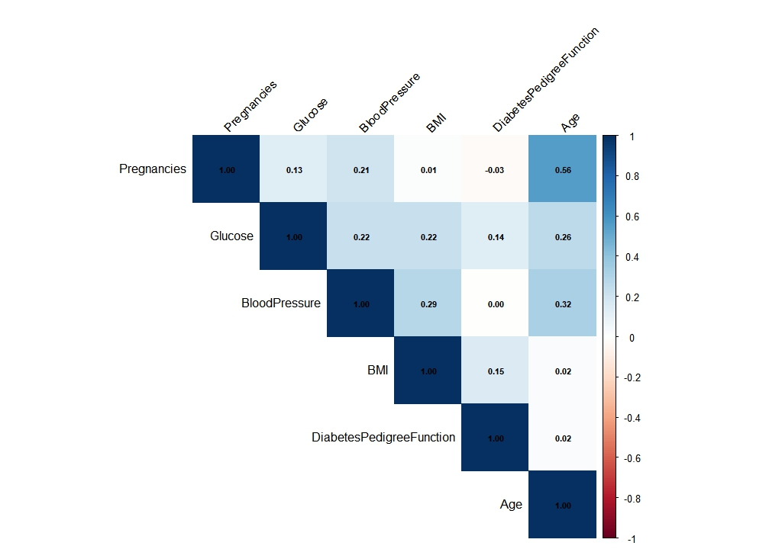
Figure 9 – Pearson correlation matrix heatmap for continuous variables
Darker blue indicates stronger positive correlation. Note: heatmap uses Pearson for all pairs as a visual overview; Spearman results in Table 5 are the authoritative findings for skewed variables.
The heatmap confirms the patterns found in individual analyses. Age and Pregnancies show the strongest inter-variable correlation (0.56 by Pearson, 0.617 by Spearman). Age and BloodPressure show a moderate positive relationship (0.32). Glucose and BMI show a weak positive link (0.22). Pregnancies and BMI show essentially no correlation (0.01).
  - Supplementary Analysis (Blood Pressure and Diabetes Status
The point-biserial correlation between BloodPressure and Outcome was r = 0.167 — the weakest of the four diabetes-status associations. But a correlation coefficient and a group mean comparison ask different questions. The group comparison showed that diabetic participants had a mean blood pressure of 75.25 mmHg (SD = 12.29) compared to 70.91 mmHg (SD = 12.17) among non-diabetic participants — a difference of 4.34 mmHg.
A Welch two-sample t-test confirmed this difference was statistically significant (t = −4.53, df = 499.56, p < 0.001), with a 95% confidence interval for the mean difference of −6.22 to −2.46 mmHg.
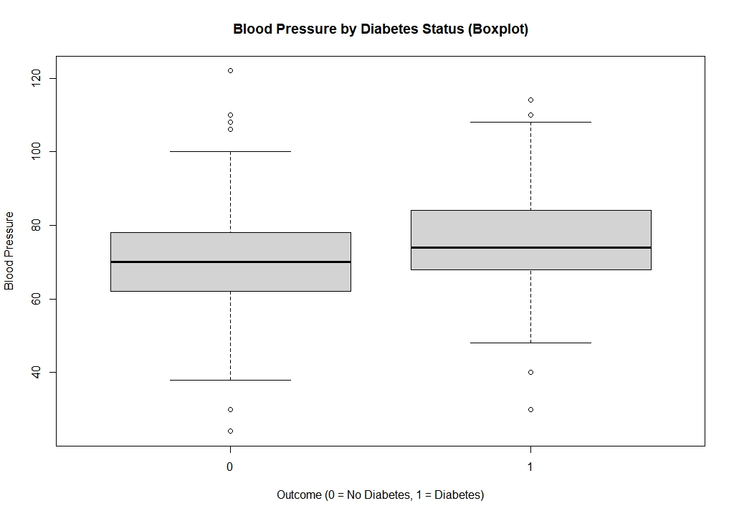
Figure 10 – Boxplot of BloodPressure by diabetes status. Diabetic participants (Outcome = 1) had a higher median blood pressure, but the distributions overlap substantially.
The boxplot shows why the correlation was weak despite the significant group difference. Both distributions span a wide range, and there is heavy overlap between diabetic and non-diabetic participants. The 4.34 mmHg difference, while real and statistically detectable, is also clinically modest — generally below the 5 mmHg threshold considered meaningful in blood pressure medicine.
Statistic | Non-Diabetic (0) | Diabetic (1)
Mean BloodPressure (mmHg) | 70.91 | 75.25
SD | 12.17 | 12.29
n | 475 | 249
Table 6 – BloodPressure group statistics by diabetes status.
Welch t-test: t = −4.53, df = 499.56, p < 0.001. 95% CI for mean difference: −6.22 to −2.46 mmHg.
- Discussion
  - Diabetes Status Associations
Glucose had the strongest association with diabetes status at r = 0.488. That isn't surprising — elevated blood glucose is the defining feature of Type 2 diabetes, so a correlation in this range is exactly what you would expect if the measurements are meaningful. What is worth noting is that the correlation is moderate, not strong. A coefficient of 0.488 means glucose and diabetes status share roughly 24% of their variance. That is a real signal, but it also means many people with normal glucose levels have diabetes in this dataset, and many with elevated glucose do not. Glucose alone does not cleanly separate the two groups.
BMI came second at r = 0.299. The relationship between obesity and Type 2 diabetes is well established — excess adiposity contributes to insulin resistance — so the positive direction is expected. The effect size is smaller than Glucose, which is consistent with the understanding that BMI captures a risk factor rather than a direct metabolic marker.
Age produced r = 0.246. Older participants were more likely to have diabetes, but the association was weaker than either Glucose or BMI. This might partly reflect that age acts through other variables — older women have had more time to develop metabolic dysfunction — rather than aging being itself a direct cause.
BloodPressure was the weakest correlate at r = 0.167. The supplementary analysis revealed that diabetic women had statistically significantly higher mean blood pressure (75.25 vs 70.91 mmHg, p < 0.001). But the group difference was only 4.34 mmHg, and the distributions overlapped heavily. Blood pressure is associated with diabetes status in this dataset, but it is not a useful standalone discriminator between diabetic and non-diabetic individuals. The correlation coefficient and the t-test together tell a consistent story: there is a real group difference, but it is small relative to within-group variance.
  - Relationship Among Risk Factors
The strongest association in the entire study was Age vs Pregnancies at ρ = 0.617. This is not a surprising finding in isolation — older women have had more reproductive years. But it matters analytically. Age and Pregnancies share substantial information with each other while both showing only weak associations with diabetes status (r = 0.246 for Age vs Outcome; Pregnancies was not directly tested against Outcome but has historically shown weak associations in this dataset). The implication is that demographic variables are tracking the same underlying dimension — life stage — rather than providing independent windows into diabetes risk.
Age vs BloodPressure produced r = 0.325, a moderate positive relationship. Blood pressure tends to rise with age; this is a well-established physiological pattern. The correlation here is consistent with that expectation.
Glucose vs BMI produced r = 0.223. Higher BMI is plausibly linked to impaired glucose regulation through insulin resistance, so the positive direction makes biological sense. The weak magnitude suggests the relationship is real but noisy — BMI captures only one dimension of metabolic health.
Pregnancies vs BMI produced ρ = −0.002, p = 0.967. This is a null result worth stating clearly: parity and body composition were effectively unrelated in this dataset. The expectation that they might be linked — through gestational weight gain or hormonal changes from multiple pregnancies — was not supported empirically. That is a genuine finding, not an absence of one.
DiabetesPedigreeFunction showed weak positive associations with Glucose (ρ = 0.086) and BMI (ρ = 0.129). The proposed mechanism — that a genetic predisposition to diabetes operates partly through insulin resistance, which is associated with both elevated glucose and higher adiposity — is plausible. The small effect sizes suggest DPF captures familial risk but that risk does not translate cleanly into measurable metabolic differences in a cross-sectional sample.
  - Clinical Implications
Clinical measurements provided more information about diabetes status than demographic or familial variables. Glucose and BMI are the variables most worth measuring if the goal is to identify who is at risk. Age and blood pressure are associated with diabetes status but add less independent signal. The Diabetes Pedigree Function, while theoretically meaningful, showed weak associations in practice.
The blood pressure finding is clinically interesting. The 4.34 mmHg difference between diabetic and non-diabetic groups is statistically significant but clinically modest. Clinical guidelines for hypertension treatment typically use thresholds well above 5 mmHg. Blood pressure monitoring in a diabetes-risk context may still be warranted — hypertension and diabetes frequently co-occur, and both are cardiovascular risk factors — but blood pressure alone is not a useful screening marker.
  - Population Context
All findings are specific to the Pima Indian population. This group has a historically documented high prevalence of Type 2 diabetes — roughly nineteen times higher than comparable populations in studies from the 1970s (Knowler et al., 1978). This has two implications for interpreting the results. First, correlations involving direct metabolic indicators like Glucose and BMI may be stronger here than in a more heterogeneous population, because diabetes and metabolic dysfunction are more prevalent and the underlying signal is stronger. Second, the genetic and environmental homogeneity of the Pima population means DPF-related correlations may be attenuated — if most participants share a similar familial risk profile, DPF explains less variation in outcomes. Findings should not be generalised to men, other ethnic groups, or populations with different diabetes prevalence.
- Limitations
Several limitations affect how these results should be read.
- Cross-sectional design. The dataset captures a single point in time for each participant. Correlations describe associations, not causal relationships. A positive correlation between Glucose and diabetes status cannot tell us whether elevated glucose precedes or follows the disease process.
- Missing data handling. Listwise deletion removed 44 rows and reduced the sample by 5.7%. If the missingness was not random — if, for example, sicker patients were more likely to have missing values — this could introduce bias into the correlation estimates.
- Excluded variables. Insulin and SkinThickness were removed due to extreme missingness. Both carry clinically relevant information — serum insulin is directly relevant to insulin resistance, and skin fold thickness captures one measure of adiposity. Excluding them may have weakened associations that would otherwise be detectable.
- Multiple comparisons. Eleven correlation tests were run at α = 0.05 without applying a Bonferroni correction or False Discovery Rate adjustment. The probability of at least one false positive across eleven tests is non-trivial. The DPF vs Glucose finding (ρ = 0.086, p = 0.021) is the most vulnerable — it is the smallest effect size and the p-value closest to the threshold. It may not survive correction.
- Heteroscedasticity. The Age vs BloodPressure scatterplot showed mild heteroscedasticity — variance in blood pressure was greater at younger ages. Pearson correlation was retained because the overall linear trend was clear and the sample size was large, but the coefficient should be read with this caveat.
- Population specificity. The study population consists exclusively of adult women of Pima Indian heritage. The findings are not generalisable to men, other ethnic groups, or populations with different disease prevalence. The correlation matrix heatmap also uses Pearson coefficients for all pairs, including those for which Spearman was the primary method. It provides a visual overview only.
- Conclusion
This study examined 11 correlation pairs across three methods — point-biserial, Pearson, and Spearman — to investigate how clinical, demographic, and familial characteristics relate to diabetes status and to one another among women in the Pima Indians Diabetes Dataset.
The central finding is straightforward: clinical variables were more informative about diabetes status than demographic or familial variables. Glucose had the strongest association at r = 0.488, followed by BMI at 0.299, Age at 0.246, and BloodPressure at 0.167. All four were statistically significant.
Among the predictor variables themselves, Age and Pregnancies were strongly correlated (ρ = 0.617) but both showed weak associations with diabetes status. Demographic variables appear to track a shared life-stage dimension rather than providing independent information about diabetes risk. The null result for Pregnancies vs BMI (ρ = −0.002) was notable — a theoretically plausible link was not supported by the data.
Familial risk, measured by the Diabetes Pedigree Function, showed only weak associations with Glucose and BMI. The DPF vs Glucose finding (ρ = 0.086, p = 0.021) is the most uncertain result in the study and should be read cautiously given the absence of a multiple-comparison correction.
The supplementary blood pressure analysis illustrated an important methodological point: a weak correlation and a statistically significant group difference are not contradictory. Diabetic women had higher mean blood pressure (75.25 vs 70.91 mmHg), but the distributions overlapped so heavily that blood pressure alone cannot distinguish the two groups.
Future work could extend these findings using multivariate logistic regression, which would allow the independent contributions of multiple risk factors to be examined simultaneously while controlling for their intercorrelations. The glucose-diabetes association in particular would likely remain the dominant signal, but regression would make it possible to quantify how much information BMI, age, and the other variables add beyond glucose alone.
- References
- Field, A., Miles, J., & Field, Z. (2012). Discovering statistics using R. SAGE Publications.
- Knowler, W. C., Bennett, P. H., Hamman, R. F., & Miller, M. (1978). Diabetes incidence and prevalence in Pima Indians: A 19-fold greater incidence than in Rochester, Minnesota. American Journal of Epidemiology, 108(6), 497–505. https://doi.org/10.1093/oxfordjournals.aje.a112648
- R Core Team. (2025). R: A language and environment for statistical computing. R Foundation for Statistical Computing. https://www.R-project.org/
- UCI Machine Learning Repository. (n.d.). Pima Indians Diabetes Database. Retrieved June 22, 2026, from https://archive.ics.uci.edu/dataset/34/diabetes
- World Health Organization. (2024, November 14). Diabetes. https://www.who.int/news-room/fact-sheets/detail/diabetes

